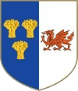
Knightly Herald
Provincial Priory of Cheshire and North Wales
September 2026
Edition
Provincial Priory Of  Cheshire and North Wales  Annual Provincial Meeting  Saturday 5th June 2027  Cheshire View  Plough Lane  Cheshire  CH3 7PT | Provincial Priory Of Malta  Cheshire and North Wales  Annual Provincial Meeting  Tuesday 27th October 2026  Maesgwyn Hall,  Mold Road,  Wrexham  Clwyd LL11 2AF
Team Visits 2026/2027  05/10/2026 Royal Edward 14 Hyde  26/11/2026 St. David 454 Rhewl-Mostyn  01/02/2027 Temple 327 Sandbach  24/02/2027 De Tabley 100 Willaston (TBC) | Diary Dates 2026/2027  09/11/2026 Gt. Priory of Malta Gt. Queen St.  19/05/2027 Gt. Priory Gt. Queen St.  05/06/2027 Provincial Priory Cheshire View  25/07/2027 Sunday Luncheon Cheshire View  26/10/2027 Provincial Priory Malta Maesgwyn Hall  08/11/2027 Gt. Priory of Malta Gt. Queen St.
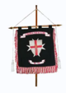  Croes Newydd Preceptory No.603  Friday 18th September  Maesgwyn Hall,  Mold Road,  Wrexham  Clwyd  LL11 2AF | De L’Isle Adam Preceptory No. 234  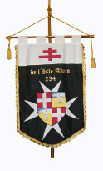  Thursday 24th September 6.15pm  Freemasons Hall,  Queen Street,  Chester  Cheshire  CH1 3LG
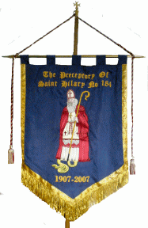  The Preceptory of St. Hilary No. 184  Saturday 12th September (1pm)  The Masonic Temple,  27 Clifton Road,  Birkenhead  Wirral  CH41 2SF | 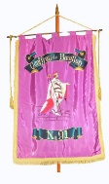  Geoffroy de Bouillon Preceptory No. 91  Thursday 17th September  The Masonic Temple  27 Clifton Road  Birkenhead  Wirral  CH41 2SF
St. Salem Preceptory No. 15  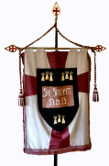  Thursday 24th September  Mill Street,  Congleton  Cheshire  CW12 1AG | Preceptory of Faith and Hope No. 326  Friday 18th September  Masonic Hall  Stockport  SK1 3UA


Produced by E. Kt. Steve Parker Prov. Herald steveparker1@gmail.com

