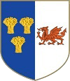
Knightly Herald
Provincial Priory of Cheshire and North Wales
May 2026
Edition
Provincial Priory Of  Cheshire and North Wales  Annual Provincial Meeting  Saturday 6th June 2026  Cheshire View  Cheshire CH3 7PT | Provincial Priory Of  Cheshire and North Wales  Annual Malta Meeting  Wednesday 25th November 2026  Maesgwyn Hall  Wrexham LL11 2AF
Kt Regalia  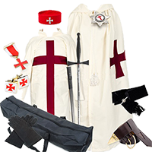  Ask your Preceptory Registrar  or available from the usual suppliers | Special Event Notice  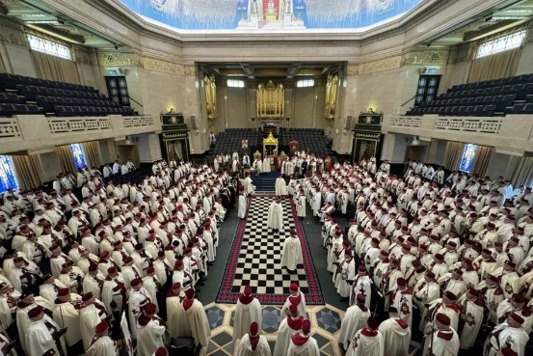  Annual Meeting of Great Priory 2026 Wednesday 20th May at 12.30pm,  Annual Meeting of Great Priory Malta 2026  Monday 9th November 2026  Freemasons Hall, Great Queen Street, London
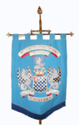  The de Tabley Preceptory No 100  2nd Thurs May (14th)  The Masonic Hall,  Willaston,  Nantwich  CW5 7ER | 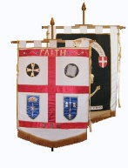  Preceptory of Faith and Hope No. 326  3rd Friday in May (15th)  Meeting at  Stockport Guild Hall  pending  Clay Lane re-building
The Preceptory of St. David No. 454    3rd Thursday in May (21st)  The Lady Augusta Hall,  Rhewl, Holywell  Flintshire  CH8 9HW | 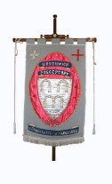  Northwich Preceptory No. 558  No longer meeting
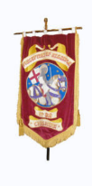  The Preceptory of St. George No. 318  Meets in May  Freemasons Hall Cheshire View  Plough Lane  Christleton  CH3 7BA | 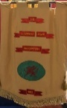  The Llewelyn Fawr Preceptory No. 685  4th Friday in January (22nd)  Freemason’s Hall  108 Mostyn Street  Llandudno  LL30 2SW

Produced by E. Kt. Steve Parker Prov. Herald steveparker1@gmail.com

