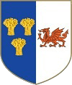
Knightly Herald
Provincial Priory of Cheshire and North Wales
January 2026
Edition
Provincial Priory Of  Cheshire and North Wales  Annual Provincial Meeting  Saturday 6th June 2026  Cheshire View  Cheshire CH3 7PT | Provincial Priory Of  Cheshire and North Wales  Annual Malta Meeting  Wednesday 25th November 2026  Maesgwyn Hall  Wrexham LL11 2AF
Kt Regalia  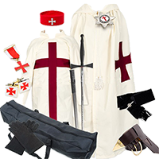  Ask your Preceptory Registrar  or available from the usual suppliers | Special Event Notice  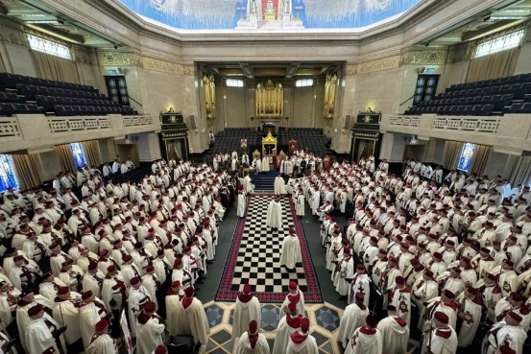  Annual Meeting of Great Priory 2026 Wednesday 20th May at 12.30pm,  Freemasons Hall, Great Queen Street, London
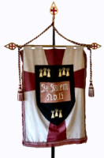  St. Salem Preceptory No. 15  4th Thursday in January (22nd)  The Masonic Hall, Congleton  Cheshire  CW12 1AG | 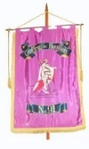  Geoffroy de Bouillon Preceptory No. 91  3rd Thursday in January (15th)  The Masonic Temple 27 Clifton Road  Birkenhead  CH41 2SF
The Preceptory of St. Hilary No. 184  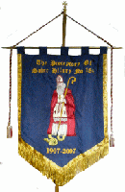  2nd Saturday in January (10th)  The Masonic Temple, 27 Clifton Road,  Birkenhead  CH41 2SF  FULL TEAM VISIT | 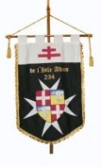  De L’Isle Adam Preceptory No. 234  Last Thursday in January (29th)  Freemasons Hall, Queen Street,  Chester  CH1 3LG  INSTALLATION MEETING
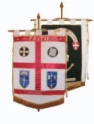  Preceptory of Faith and Hope No. 326  3rd Friday in January (16th)  The Masonic Hall, 36 Clay Lane,  Altrincham  WA15 7AB  INSTALLATION MEETING | 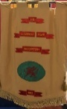  The Llewelyn Fawr Preceptory No. 685  4th Friday in January (23rd)  Freemason’s Hall 108 Mostyn Street  Llandudno  LL30 2SW  PROVINCIAL PRIOR VISIT

Produced by E. Kt. Steve Parker Prov. Herald steveparker1@gmail.com

