Preceptories of The Order
In Cheshire and North Wales
meet at

Hyde | Royal Edward Preceptory | 14
Congleton | St. Salem Preceptory | 15
Birkenhead | Geoffroy de Bouillon Preceptory | 91
Nantwich | The de Tabley Preceptory | 100
Chester | Grosvenor Preceptory | 132
Birkenhead | The Preceptory of St. Hilary | 184
Wallasey | Palestine Preceptory | 217
Menai Bridge | Menai Preceptory | 231
Chester | De L'Isle Adam Preceptory | 234
Christleton and Wrexham | The Preceptory of St. George | 318
Sale | Preceptory of Faith & Hope | 326
Sandbach | The Temple Preceptory | 327
Holywell | The Preceptory of St. David | 454
Macclesfield | Northwich Preceptory | 558
Wrexham | The Croes Newydd Preceptory | 603
Christleton | The Preceptory of St.Werburgh | 605
Llandudno | Llewelyn Fawr Preceptory | 685

To qualify Freemasons must be
Christian and must have been Exalted into the Royal Arch

Revised November 2021

The Provincial Priory
of
Cheshire and North Wales

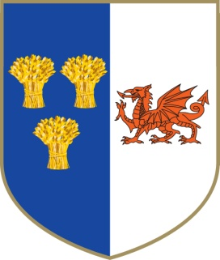

As Provincial Prior I would be delighted to welcome you into our Order. We are a very close knit and friendly Order of over 400 Knights in 18 Preceptories. The historical nature of the ritual in the Order of the Temple and the attached Order of Knights of Malta is very interesting. Preceptories generally meet 3 or 4 times a year and there is an Annual Provincial Meeting at Christleton on the first Saturday in June, to which all members are welcome.

Alan Pierce
Provincial Prior

Provincial Prior.

Right Eminent Knight
Alan Pierce

***
Provincial Sub-Prior.
Eminent Knight Peter Butler

***
Provincial Vice Chancellor.
Eminent Knight Anthony Lloyd

***

For more information
please contact
The Provincial Vice-Chancellor

Email: vc@cheshireandnorthwaleskt.org.uk
Website:
www.cheshireandnorthwaleskt.org.uk

Regalia for a Knight of the Order

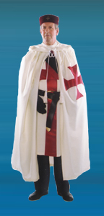

Comprising of

Cap and Badge
Tunic: Sash: Star: Knights Cross Jewel
Belt with frog and Sword
Mantle: Black Gloves
To help reduce the initial cost, used Regalia
can often be obtained by contacting
Preceptory Registrars

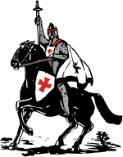

The Origins
According to legend, the Order of Knights Templar was founded in 1118 to protect pilgrims heading for Jerusalem and the Christian Holy places, where the small band of warrior monks established a headquarters.
In the year 1118 AD King Baldwin II granted the Templars quarters on the Temple Mount and this forms the link to the Royal Arch.
Many men, of noble birth, joined the ranks of the Templar Order. Those who were unable to join often gifted the Templars with land and other valuables.

Modern Masonic association with these Medieval defenders of the Christian Holy Places is linked by the ceremony of Installation in which the Candidate takes the part of a Pilgrim who, by symbolically embarking on a Crusade, is elevated to Knighthood.

The ceremony is very realistic and the regalia spectacular, based upon that worn by the Medieval Knights.

An introduction to the
Order of
Knights Templar

The United Religious,
Military and Masonic Orders
of the Temple and
of St. John of Jerusalem,
Palestine, Rhodes and Malta in
England and Wales
and its Provinces Overseas.

